**Install apache2 on ubuntu :**

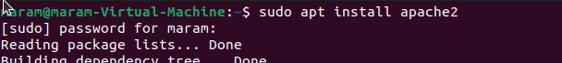

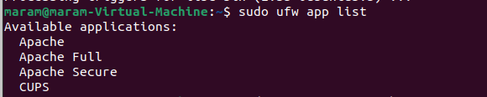



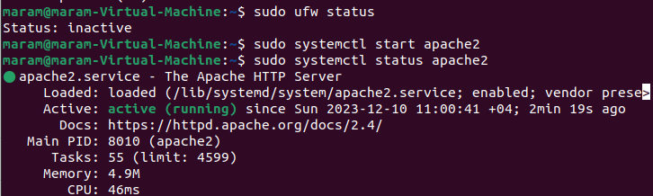

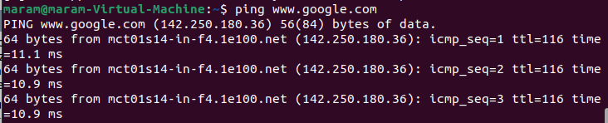

**Install apache on centos:**

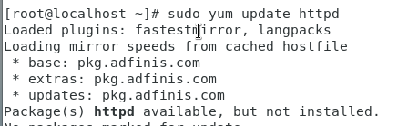

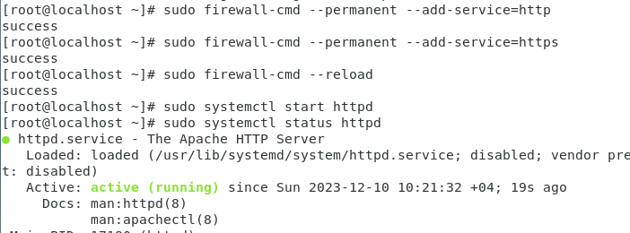

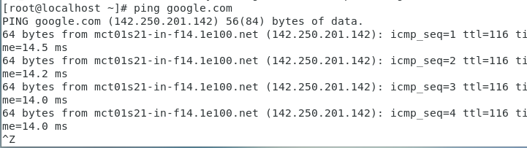

**Install sql mariadb server on centos:**

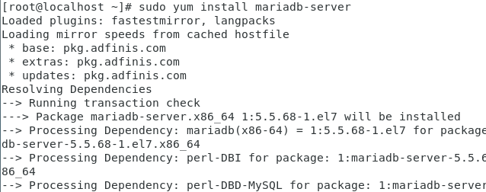

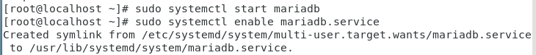

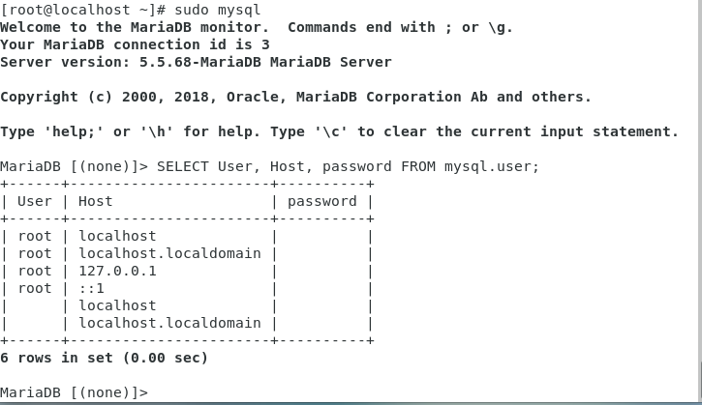

**Install DHCP on centos:**





